M. Tyler Moffat
11/24/24
NoSQL Project Report
Reflection:
I approached the project by first learning what I could about the framework that we were using, unqlite. I looked up some documentation, and read through some examples of how the library worked. From there, I opened the project file and played around with the data that was loaded in. To get a better understanding of how the data was stored in the collection, I began by running a for loop to print out the data stored within. I saw that it was basically a list of dictionaries, with each dictionary being an entry in the database. With a better grasp on the collection object and data storage, I felt that it was time to start working on the three functions I needed.
First, I started with the FindBusinessBasedOnCity since I felt that of the two actual query functions, it would be the easiest. I began with opening the appropriate file that the results would be saved to and went back to the unqlite documentation to figure out how to make a selection query. Thats when I found the filter function for the collection object. It takes an expression as input and returns a list of entries (in the form of dictionaries) to which the inputted expression is true. Since we only needed to select entries over the city field, I used the lambda expression obj[‘city’] == cityToSearch as the filter input. This would return only entries where the city field is equal to the selected city. I then used a for loop to iterate through the list of selected entries and wrote the required fields to the output file.
I then decided to work on the distance function since it would be required for the FindBusinessBasedOnLocation function. This was fairly simple, since the project description already gave us the formula we needed. All I had to do was modify it so that it used Python syntax, such as using the Math library, and I simplified the formula a bit by using math.sin(delta_lat/2)**2 instead of math.sin(delta_lat/2)*math.sin(delta_lat/2) since the latter is clunky and hurts readability. I made sure to test the function by running it and comparing it to an online version I found. My version was off by a fraction of a mile, so I felt that it was close enough.
With the distance function done, all I had left was the FindBusinessBasedOnLocation function. I found this to be fairly simple, since I learned how to make selection queries in the previous query function, although this was more complicated. To start, I had to select any entry with a desired category. Since the function could take query for multiple different categories simultaneously, I decided to start with a for loop that would iterate through the categoriesToSearch list. I would then use a filter in the loop to select for entries that both had the category the loop index was on and was within the maximum distance using the distance function. My code would then write all the selected entries for that category to the file before moving onto the next index in the categoriesToSearch list.

Lessons Learned:
The primary lesson I learned from this project was how to effectively translate a SQL query into a NoSQL query. I am already quite experience with SQL, having used it in previous jobs, but I have never had to use any NoSQL framework. I both had to learn how to make selections with this framework and combine multiple selections into more complex queries.

Output:
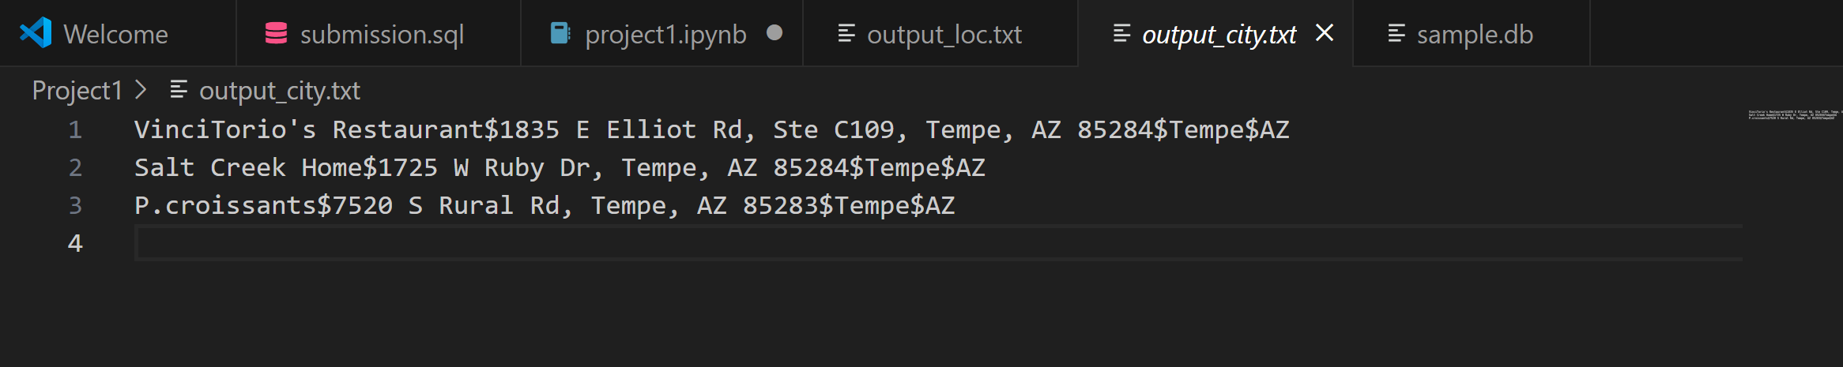
FindBusinessBasedOnCity:

FindBusinessBasedOnLocation:
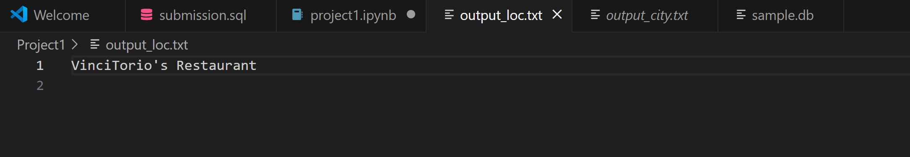

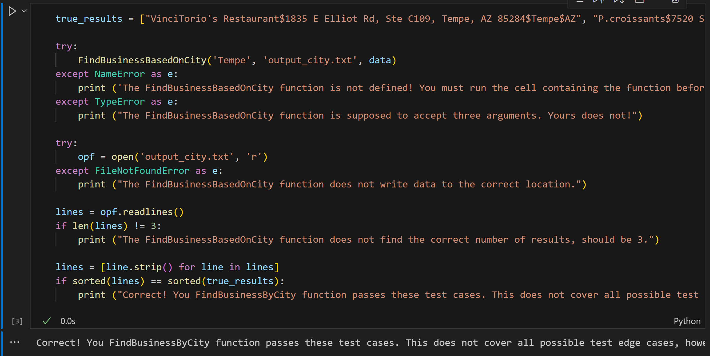
Result:
